<https://kaustubh-natuskar.github.io/moreThanFAANGM/>

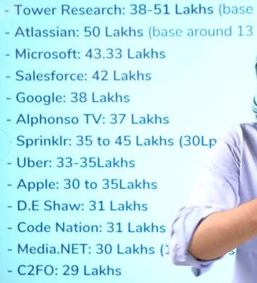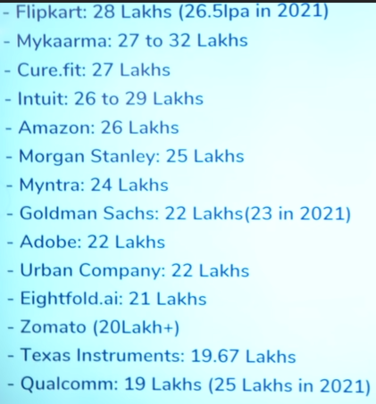

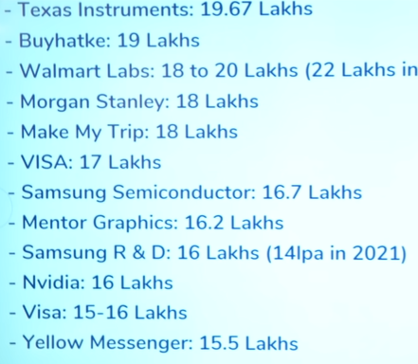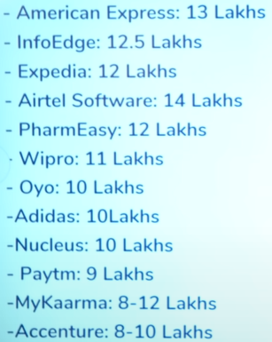

1. American Express(intern) ---> oct
2. Expedia ---> january,
3. Infosys march/april,
4. TCS april,
5. Microsoft april,
6. Sahaj August/sept
7. BuyHatke August 2020
8. Google august/september
9. NCR september
10. Amazon(intern) september
11. IHS october
12. Zeta (Intern) november
13. BrowserStack (Intern + FTE) november
14. Hackerrank (Intern) november
15. Cisco (Intern) november
16. D.E. Shaw (FTE) october/november
17. Salesforce Oct/Nov
18. Dunzo(Intern) Nov
19. Factset december
20. Coding Ninja december
21. Media (Intern + FTE) january
22. Yellow messenger jan
23. Geeksforgeeks january
24. Codenation january
25. JP Morgan january
26. Quora january
27. Goldman Sachs january
28. Bharat pe(Intern) Jan
29. Gameskraft february
30. Databricks march
31. Apptio march
32. Bytedance march
33. Innovaccer april
34. Cadence april
35. Semut.io april
36. Hike april
37. ServiceNow april
38. Sprinklr april
39. Tower Research april
40. Hotstar may
41. Myntra may
42. Paypal Sept
43. Cvent
44. Tekion Corp Sahil Shrivastav
45. Josh
46. Pluang \
47. Compass
48. Nutanix
49. Twilio
50. Rubrik
51. Cohesity
52. Confluent
53. Snowflake
54. Rippling
55. Stripe
56. Tokopedia